Milestone 2: Supply Chain Structure Modeling & Process Analysis
Cass / Cass Light / Cass 0.0 Brewing Process
TEAM4 (나태양, 유재호, 윤채리, 이대희, 최지안)
Scope | Strategy | Main shared resource
Raw material receipt to matured liquid beer; packaging excluded | MTS for the Cass family; brewing decisions made before realized demand | Fermenters and upstream brewing assets can be re-sequenced across variants
Assumption basis: Plant-level numbers are not public, so the capacities below are structured engineering estimates using one brew batch as the unit of analysis.
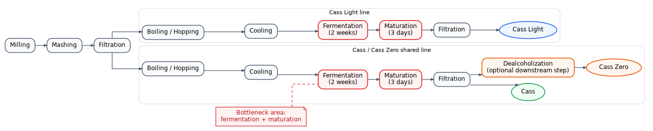
Figure 1. Team process-flow sketch showing the shared brewing line and the fermentation/maturation bottleneck.
1) Process flow, bottleneck, capacity, utilization, and flow time

Process logic. All three products share milling/mashing → boiling → cooling → fermentation → maturation. Cass 0.0 then adds de-alcoholization. With fermentation lasting about 14 days and maturation about 3 days, tank occupancy drives system throughput.

Note: All capacities and inventory choices are structured estimates for milestone discussion, not audited brewery data.
Stage | Flow time | Capacity | Resource | Load | Util. | Comment
Milling | 1 h | 8.0/day | 1 mill | 1.20 | 15% | Slack
Mashing | 4 h | 6.0/day | 1 line | 1.20 | 20% | Not constraining
Filtration | 2 h | 8.0/day | 1 filter | 1.20 | 15% | Slack
Boiling/Hopping | 2 h | 12.0/day | 1 kettle | 1.20 | 10% | Slack
Cooling | 1 h | 24.0/day | 1 cooler | 1.20 | 5% | Slack
Fermentation | 14 days | 0.071/tank/day | 20 tanks | 1.20 | 84% | Bottleneck
Maturation | 3 days | 0.333/tank/day | 10 tanks | 1.20 | 36% | Secondary constraint
Filtration | 1 h | 12.0/day | 1 filter | 1.20 | 10% | Slack
De-alcoholization | 8 h | 3.0/day | 1 unit | 0.12 | 4% | Cass 0.0 only

Interpretation. At assumed demand of 1.2 batches/day, fermentation utilization is about 84%, much higher than the rest; therefore fermenter turns determine family-level capacity.

2) Production strategy, push-pull boundary, and forecasting
Production strategy. The Cass family is best modeled as MTS because brewing lead time is long, demand is repetitive, and retail service requires immediate availability.
Push-pull boundary. The push portion includes brewing and tank scheduling up to matured beer; the pull portion begins when downstream channels draw from finished inventory. Because packaging is excluded, the practical boundary is just after maturation (and after de-alcoholization for Cass 0.0).
Forecasting view. Forecast error is likely smallest for flagship Cass, moderate for Cass Light, and largest for Cass 0.0 because non-alcoholic demand is more promotion-sensitive and less stable.
3) Inventory mapping and where variability hurts most
Inventory location | Type | Role in chain | Assessment
Raw materials | Cycle + safety | Supports brew schedule and supplier lead time | Needed, but not the main constraint
Pre-fermentation WIP | Cycle WIP | Very short unless waiting for a fermenter | Waiting here means poor tank synchronization
Fermentation / maturation tanks | Cycle inventory | Beer stays 17 days in process | Dominant inventory investment
Finished beer at brewery/DC | Safety + seasonal + pipeline | Protects service level and transit needs | Best place to absorb demand variability
Summer pre-build | Seasonal | Build ahead of peak demand | Most relevant for flagship Cass

Inventory implication. If the firm wants high shelf availability, safety stock should be concentrated in finished goods rather than increasing fermenter-side WIP. Extra WIP before the bottleneck lengthens flow time without raising output.

